Community Drinking Water Safety & Security Plan (DWSSP)

Community Details
Village Name
Area/Province
GPS Coordinates | Lat: |  | Long:
No of Households
Village Population
Village Contact Person
Revision No: Date:

Section 1 – Water Committee
Name | Current Role in Water Committee / Community | Skills Available / Interest in the Water Supply | Contact Details  (Address/Phone/E-mail)

Section 2 – Description of Current Supply
System Map/Flow Diagram
Please draw a map/flow diagram of the current water and waste system
If map is attached separately, please tick here

Section 2 – Description of Current Supply
Existing Water Supply
Piped Supply  (River/Spring) | Rainwater Capture |  | Groundwater | Water Storage | Water Distribution
Measured Flow from Source (litres/min)  2A | No of Buildings Collecting  2C | Average Roof Area (m²)  2D | Measured Flow (litres/min)  2F | Amount Available (litres)  2H | Number of Distribution Points
Supply per year
(litres per year)
2E = 2C x 2D x 0.7 x Av_Rainfall_per_year x 1000
0.7 is efficiency factor
x 1000 to convert m³ to litres
Supply per day (litres/day)  2B = 2A x 1440 mins |  |  | Supply per day (litres/day)  2G = 2F x Minutes Used/Day |  | Measured Flow (litres/min)
Water Quality Result | Water Quality  Result |  | Water Quality Result | Water Quality Result | Water Quality Result
Uses of the system
Drinking Food Preparation Hand Washing Bathing Toilets

Other (Please explain) ………………………………..
Treatment Methods
Filtration Chlorine UV Light

Other (Please explain) ………………………………..
Existing Waste System
Number of Rubbish Pits ……..
Type of Toilets |  |  |  | Number of Each Type
VIP (pit and bush)
Septic Tank
Pour-Flush
Other (Please list)

Section 3A –Assessment (Water Access/Availability)
Water Availability
Number of People in Community  3A | Estimated Daily Usage  (litres per day)  [3B = 3A* N litres/day]  3B (Select value for N) | Storage Required (litres)  [3C = 3B]  3C | Estimated Usage by Population per year (litres per year)  [3D = 3A*N l/day *365]  3D
Water Quantity – Piped Supply System or Groundwater Source
Is the supply in 2B/2G enough to meet demand 3B? Yes No
If NO, look to improve the system design to increase flow (Please tick)
Is this source available at all times during the year? Yes No
If NO, develop/strengthen Additional Water Source/s (Please tick)

Water Quantity – Rainwater Capture (ONLY ANSWER IF RWC IS ONLY WATER SOURCE)
Is the supply in 2E enough to meet demand 3D? Yes No
If NO, develop Additional Water Source/s (Please tick)
Water Storage – Piped Supply System
Is the current storage 2H enough to meet the required storage amount 3C?
Yes No (If NO, add More Storage)
How much extra Storage is required? litres
Number of tanks required $\left[\frac{Storage Required}{5000 OR 10000}\right]$ tanks
Water Quantity – Distribution Points
Are flow rates more than 6 litres/min at the tapstand/s? Yes No
If NO, look to improve the system design to increase distribution flow (Please tick)
REMEMBER: Doing this can change pressures and flows in the system. It is important to get some technical assistance when planning to change flows in the distribution system.
Water Access (Only Upgrade if enough water is supplied by the system)
Water Access
Do more than 5 households share 1 distribution point? Yes No
Are any distribution points more than 200m away (2-3mins walk)? Yes No
If YES to either question, then you need extra distribution points (Please Tick)
REMEMBER: Doing this can change pressures and flows in the system. It is important to get some technical assistance when planning to increase the distribution system.
How many extra points are required? ………….. PLEASE MARK ON COMMUNITY MAP

Community Drought Risk and Preparedness
Risk Factors | Mitigation Measures | Risk | Improvements
Significant dry periods >3months  Variation in source water level/s  Significant leaks in system  Other (Please list) | High storage capacity  Multiple water sources  Water resource management (WRM) undertaken  HWTS prepared  Other (Please list) | High  (Action Needed Now)  Medium  (Upgrades Needed)  Low  (No Action Required) | Fix/optimise system  Increase storage  Develop additional source  Implement WRM  Prepare HWTS  Other (Please list)
Community Flood Risk and Preparedness
Risk Factors | Mitigation Measures | Risk | Improvements
Significant periods of heavy rain causing unusable dirty river, spring or well water  Damage to intake, pipes, tanks  Other (Please list) | High storage capacity  Multiple water sources  Good spring or well-head protection  Water resource management (WRM) undertaken  HWTS prepared  Other (Please list) | High  (Action Needed Now)  Medium  (Upgrades Needed)  Low  (No Action Required) | Fix/optimise system  Increase storage  Develop additional source  Implement WRM  Prepare HWTS  Other (Please list)

Section 3B – Assessment (Water Safety)
Water Quality Results
E.Coli Results
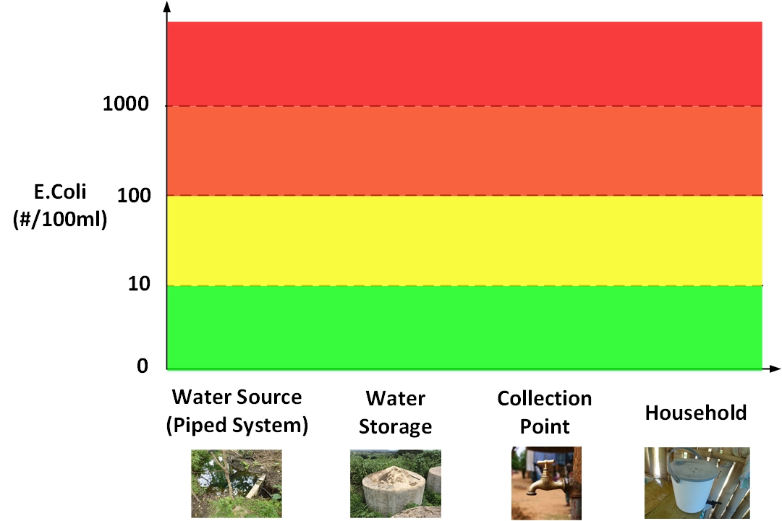
Turbidity Results
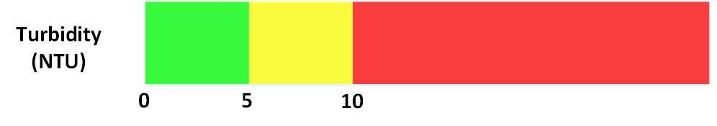
Conductivity Results
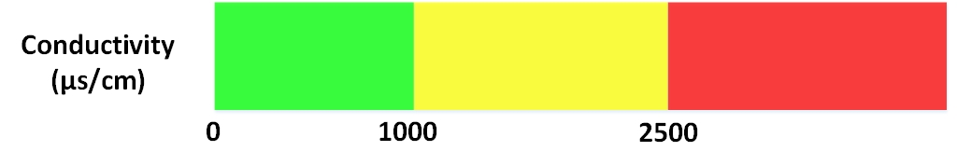
pH Results
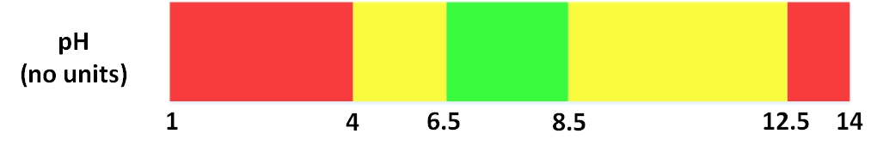

Water Safety Plan – Risk Assessment
Water Source – Surface Water Source |  |  | Do you use a Surface Water Source? (Please Tick) Yes No
Hazard | Contamination Source  (Tick if present) | Current Control Measures  (Tick if present) |  | Risk | Improvements Required
Bacteria in Water | Human houses upstream  Farm animals nearby/upstream  Crop farming  nearby/upstream  Toilet within 30m  Other (Please list) | Fencing around source  Intake screen present  Gravel or Sand Filter  Established water protection zone  Other (Please list) |  | High  (Action Needed Now)  Medium  (Upgrades Needed)  Low  (No Action Required) | Establish a water protection  zone  Build Fence  Install screen  Install Filter  Move Source  Move Toilet  Other or Temporary Improvements (Please list)
Chemicals in Water | Use of pesticides in area  Waste water discharge  in area  Algae present at source  Other (Please list) | Gravel or Sand Filter  Established water protection zone  Other (Please list) |  | High  Medium  Low | Establish a water protection  zone  Install Filter  Move Source  Other or Temporary Improvements (Please list)
Bad Colour or Taste | Soil Erosion at source  Other (Please list) | Gravel or Sand Filter  Storage and settlement  tanks  Other (Please list) |  | High  Medium  Low | Install Filter  Install Storage  Other or Temporary Improvements (Please list)
Bad Flow or Pressure | High pressure in taps  Significant leaks in pipes  Other (Please list) | Minimum Head Device  Pressure Box  Other (Please list) |  | High  Medium  Low | Install Head Device  Install Pressure Box  Other or Temporary Improvements (Please list)

Water Source – Spring Source |  |  | Do you use a Spring Source? (Please Tick) Yes No
Hazard | Contamination Source  (Tick if present) | Current Control Measures  (Tick if present) |  | Risk | Improvements Required
Bacteria in Water | Animals can access source  Spring box/cover is dirty  Silt/soil/dirt near source  Surface water can flow  Into spring water  Toilet within 30m  Other (Please list) | Spring box and cover  Fencing around source  Air vent (Clean)  Diversion ditch  Established water protection  zone  Other (Please list) |  | High  (Action Needed Now)  Medium  (Upgrades Needed)  Low  (No Action Required) | Establish a water protection  zone  Build Fence  Build spring box  Install/Clean cover, vent  Dig diversion ditch  Move Toilet  Other or Temporary Improvements (Please list)
Chemicals in Water | Use of pesticides in area  Waste water discharge  in area  Algae present at source  Other (Please list) | Gravel or Sand Filter  Established water protection zone  Other (Please list) |  | High  Medium  Low | Establish a water protection  zone  Install Filter  Move Source  Other or Temporary Improvements (Please list)
Bad Colour or Taste | Silt/soil/dirt near source  Other (Please list) | Gravel or Sand Filter  Storage and settlement  tanks  Other (Please list) |  | High  Medium  Low | Install Filter  Install Storage  Other or Temporary Improvements (Please list)
Bad Flow or Pressure | High pressure in taps  Significant leaks in pipes  Overflow water at source  Other (Please list) | Overflow pipe (clean)  Pressure Box  Other (Please list) |  | High  Medium  Low | Install Head Device  Install Pressure Box  Other or Temporary Improvements (Please list)

Water Source – Rainwater Capture |  |  | Do you use a Rainwater Capture? (Please Tick) Yes No
Hazard | Contamination Source  (Tick if present) | Current Control Measures  (Tick if present) |  | Risk | Improvements Required
Bacteria in Water | Roof is dirty  Gutters are dirty  Open access to tank  Tank is cracked  Tap is leaking  Water collection area is  dirty / standing water  Pollution (e.g. trees,  Excreta etc) near system  Collection bucket dirty  Other (Please list) | Tank cover in place  Tank inlet has mesh/sieve  First flush filter  Other (Please list) |  | High  (Action Needed Now)  Medium  (Upgrades Needed)  Low  (No Action Required) | Nº  Clean roof/gutters  Install covers on tank  Install inlet mesh/sieve  Install first flush filter  Repair cracks  Repair/replace tap  Add drainage/clean  collection area  Remove pollution  Other or Temporary Improvements (Please list)
Chemicals in Water | Roof is corroded/rust  Other (Please list) | First flush Filter  Other (Please list) |  | High  Medium  Low | Install Filter  Repair/replace/paint roof  Other or Temporary Improvements (Please list)

Water Source – Groundwater |  |  | Do you use a Groundwater Source? (Please Tick) Yes No
Hazard | Contamination Source  (Tick if present) | Current Control Measures  (Tick if present) |  | Risk | Improvements Required
Bacteria in Water | Toilet within 10m of well  Toilets above well height  Other pollution within  10m of well e.g. rubbish  Standing water within 2m  of well  Broken drainage channel  Surface water can enter  From broken wall  Cracks in concrete wall  Collection bucket dirty  Other (Please list) | Fence around well  Well is sealed to 3m depth  Drainage channel installed  Established water protection zone  Other (Please list) |  | High  (Action Needed Now)  Medium  (Upgrades Needed)  Low  (No Action Required) | Establish a water protection  zone  Move toilets  Build fence around well  Repair/Install concrete  Line well to 3m depth  Repair well wall  Clean well area  Remove pollution  Other or Temporary Improvements (Please list)
Chemicals in Water | Use of pesticides in area  Waste water discharge  in area  Other (Please list) | Water treatment system  Established water protection zone  Other (Please list) |  | High  Medium  Low | Establish a water protection  zone  Install Treatment  Move Source  Other or Temporary Improvements (Please list)

Water Pump |  |  | Does your system have a water pump? (Please Tick) Yes No
Hazard | Contamination Source  (Tick if present) | Current Control Measures  (Tick if present) |  | Risk | Improvements Required
Bacteria in Water | Toilet near pump  Animals can access pump  Pump is dirty  Surface water can access  the pump  Standing water in pump  area  Other (Please list) | Protective structure for  pump  Fence around pump  Adequate drainage  around pump  Established protection zone  Diversion ditch  Other (Please list) |  | High  (Action Needed Now)  Medium  (Upgrades Needed)  Low  (No Action Required) | Establish protection zone  Clean pump and area  Build protective structure  Build fence  Move toilet  Dig diversion ditch  Other or Temporary Improvements (Please list)
Chemicals in Water | Pipes are corroded  Other (Please list) | Plastic piping  (where appropriate)  Other (Please list) |  | High  Medium  Low | Replace corroded pipe  Other or Temporary Improvements (Please list)
Damaged Pump | Exposed location  Debris loose/overhanging  Other (Please list) | Protective structure for  pump  Other (Please list) |  | High  Medium  Low | Remove debris  Build protective structure  Other or Temporary Improvements (Please list)

Water Storage – Storage Reservoir |  |  | Do you use Water Storage? (Please Tick) Yes No
Hazard | Contamination Source  (Tick if present) | Current Control Measures  (Tick if present) |  | Risk | Improvements Required
Bacteria in Water | Open access to tank  Vents/screens are dirty  Tank is cracked  Pipes are leaking  Dirty inside tank  Other (Please list) | Tank cover in place  Tank inlet has mesh/sieve  Tank has air vent  Other (Please list) |  | High  (Action Needed Now)  Medium  (Upgrades Needed)  Low  (No Action Required) | Install covers on tank  Install inlet mesh/sieve  Install air vent  Repair cracks  Repair/replace pipes  Clean tank  Other or Temporary Improvements (Please list)
Chemicals in Water | Pipes are corroded  Other (Please list) | Treatment Filter  Other (Please list) |  | High  Medium  Low | Replace corroded pipe  Install Filter  Other or Temporary Improvements (Please list)
Bad Flow or Pressure | High pressure in taps  Low pressure in taps  Significant leaks in pipes  Other (Please list) | Overflow pipe (clean)  Float valve  Other (Please list) |  | High  Medium  Low | Install overflow pipe  Install float valve  Other or Temporary Improvements (Please list)

Water Distribution – Stand Pipes |  |  | Do you use a Stand Pipes? (Please Tick) Yes No
Hazard | Contamination Source  (Tick if present) | Current Control Measures  (Tick if present) |  | Risk | Improvements Required
Bacteria in Water | Leaks in surrounding pipes  Animals access to area  Standing water in  collection area  Rubbish/pollution near  tap stand  Tap stand is cracked  Taps are leaking  Other (Please list) | Fence around stand pipe  Drainage area/channel  Other (Please list) |  | High  (Action Needed Now)  Medium  (Upgrades Needed)  Low  (No Action Required) | Nº  Build fence/s  Install drainage  Repair/replace pipe/s  Repair/replace pipe stand/s  Repair/replace tap/s  Clean collection area/s  Other or Temporary Improvements (Please list)
Chemicals in Water | Pipes are corroded  Other (Please list) | Plastic piping  Other (Please list) |  | High  Medium  Low | Nº  Replace corroded pipe/s  Other or Temporary Improvements (Please list)

Water Consumers – Households |  |  | Was this assessed during the visit? (Please Tick) Yes No
Hazard | Contamination Source  (Tick if present) | Current Control Measures  (Tick if present) |  | Risk | Improvements Required
Bacteria in Water | Non-covered storage  Containers are dirty  Household Rainwater  Dirty buckets for collection  Other (Please list) | HH Chlorine tablets  UV treatment  Boil water  Sealed storage containers  First Flush on Rainwater  Other (Please list) |  | High  (Action Needed Now)  Medium  (Upgrades Needed)  Low  (No Action Required) | Obtain sealed storage  containers  Clean/disinfect storage  Containers & buckets  Begin boiling water  Begin UV treatment  Install first flush  Obtain chlorine tablets  Other or Temporary Improvements (Please list)
Chemicals in Water | House pipes/storage  is corroded  Other (Please list) | Treatment to remove  chemicals  Other (Please list) |  | High  Medium  Low | Replace corroded pipe  Install Treatment  Other or Temporary Improvements (Please list)

Section 3C – Assessment (Sanitation System)
Toilet Sanitary Survey Result

How many toilets need replacing? …………

How many toilets need upgrading? …………
Replace/Install New Toilets
Are you replacing or installing new toilets? (Please tick) Yes No
Toilet Options (Please indicate the type and amount of toilets required)
VIP Toilet  Number Required  ……… | Pour Flush Toilet  Number Required  ……… | Septic Tank Toilet  Number Required  ………  Has soil permeability test been performed?  Yes No
Upgrade Existing Toilets
Do existing toilets require upgrading? (Please tick) Yes No
What toilet type/s do you want to upgrade? (Please tick all relevant ones)
VIP Toilet Pour Flush Toilet Septic Tank Toilet
VIP Toilet – Number requiring upgrade………….

Number requiring repairs to structure …………..
Number requiring vent in super structure …………..
Number requiring a vent with flywire …………..
Number requiring upgrade of slab/riser …………..
Number that would require lining of pit …………..
Number requiring collection pit at adequate depth …………..

Pour Flush Toilet – Number requiring upgrade………….

Number requiring repairs to structure …………..
Number requiring venting in the super structure …………..
Number requiring upgrade of slab/riser …………..
Number of collection pits requiring a cover for access …………..
Number of collection pits requiring a vent …………..
Number that would require lining of pit …………..

Septic Tank Toilet – Number requiring upgrade………….

Number requiring repairs to structure …………..
Number requiring vents …………..
Number with drainpipes requiring a vent …………..
Number with drainpipes requiring inspection access …………..
Number requiring a new septic tank …………..
Number requiring a drainage trench …………..

Section 4 – Improvement Plan
Problem/Hazard | Improvement Required | Who | Timeframe | Cost | Status  (Tick when complete)
 |  |  |  |  | Implemented
 |  |  |  |  | Implemented
 |  |  |  |  | Implemented
 |  |  |  |  | Implemented
 |  |  |  |  | Implemented
 |  |  |  |  | Implemented

Problem/Hazard | Improvement Required | Who | Timeframe | Cost | Status  (Tick when complete)
 |  |  |  |  | Implemented
 |  |  |  |  | Implemented
 |  |  |  |  | Implemented
 |  |  |  |  | Implemented
 |  |  |  |  | Implemented
 |  |  |  |  | Implemented

Section 5 – Community Management
Monitoring Schedule
System Component  (Tick if present) | What? | How Often? | Who?
5A Primary Water Source

Type……………………..
5B Secondary Water Source

Type……………………..
5C Water
Storage

Type……………………..
5D Water Treatment

Type……………………..
5E Water Distribution

Type……………………..
5F Primary Toilet Type

Type……………………..
5G Secondary Toilet Type

Type……………………..

Maintenance – What actions are needed if something is broken?
Activity | How Often? | Who? | What is needed?

Community Training – What do you need to teach the community?
Activity | How Often? | Who? | What is needed?
Emergency – What will you do in an emergency?
Activity | How Often? | Who? | What is needed?

Appendix 1
Water Quality Results
System Part | Position and Time | Temp  (°C) | pH | TDS  (mg/L) | Conductivity  (μs/cm) | Turbidity  (NTU) | Res Chlorine [if used]  (mg/L) | E.Coli  (#/100ml) | Total Coli  (#/100ml)

